# 百度

<https://passport.baidu.com/v2/?reg>

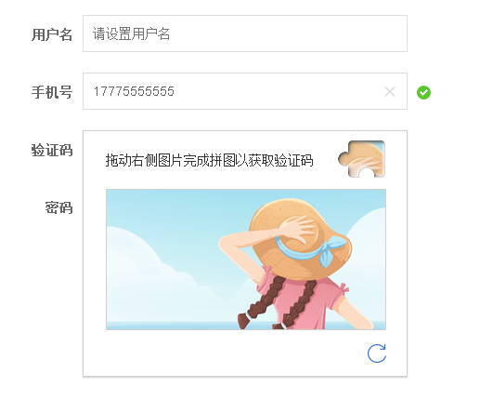

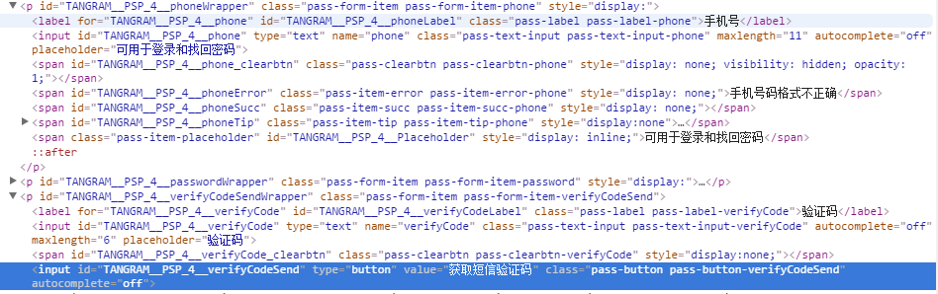

# 华为

<https://hwid1.vmall.com/oauth2/portal/regbyphone.jsp?service=http%3A%2F%2Fwww.vmall.com%2Faccount%2Fcaslogin&loginChannel=26000000&reqClientType=26&deviceID=&lang=zh-cn&InviterUserID=&Inviter=&isFromPC=1&loginUrl=https://hwid1.vmall.com/oauth2/portal/login.jsp&adUrl=&viewType=0&isDialog=0&themeName=default>

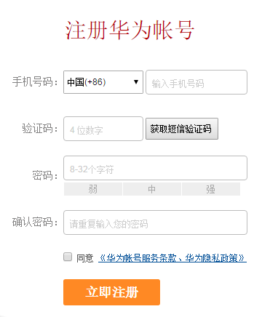

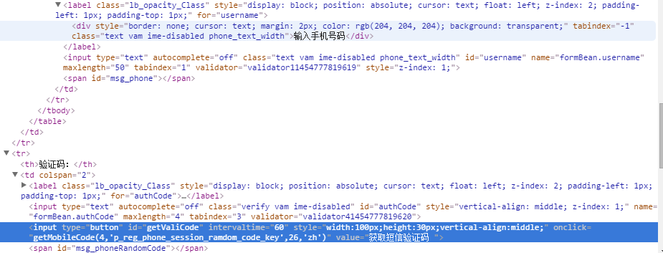

# 移动

<https://login.10086.cn/html/login/login.html?channelID=12002&backUrl=http%3A%2F%2Fshop.10086.cn%2Fmall_250_250.html%3Fforcelogin%3D1>

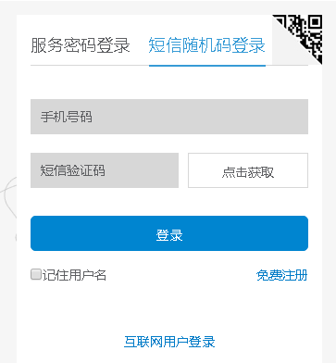

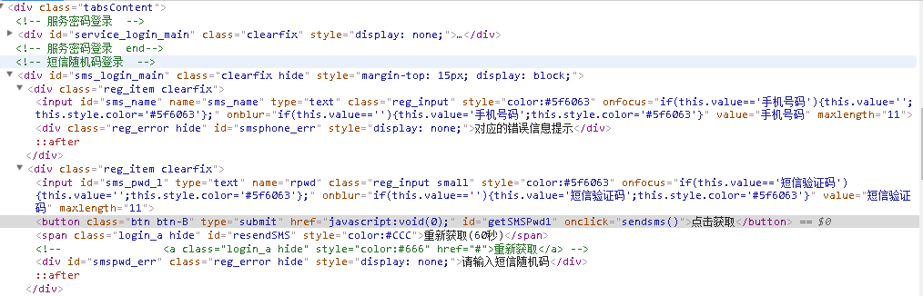

# 太平洋汽车网

<http://my.pcauto.com.cn/passport/mobileRegister.jsp>

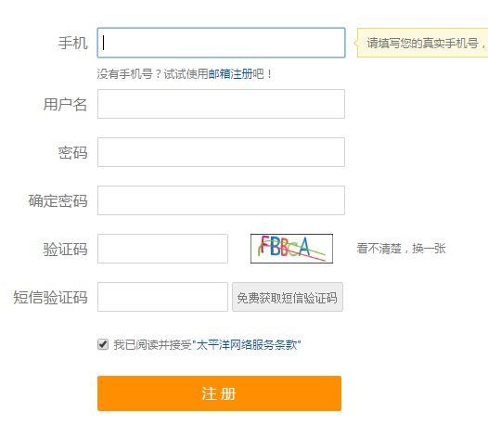

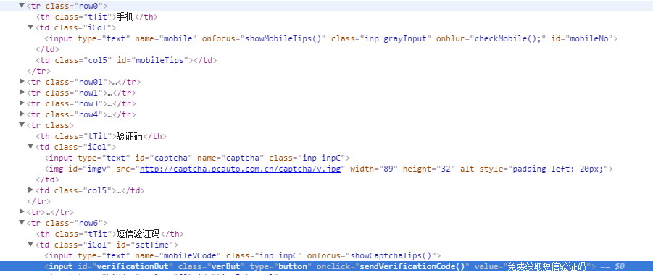

<http://captcha.pcauto.com.cn/captcha/v.jpg>

# 京东

<https://reg.jd.com/reg/person>

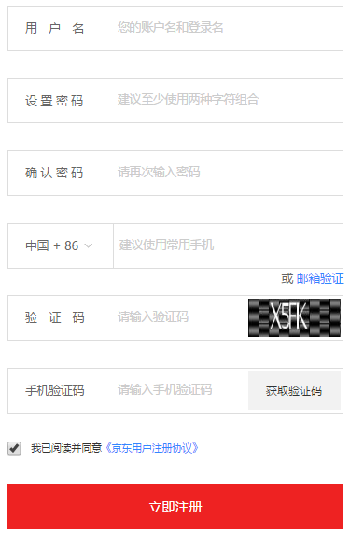

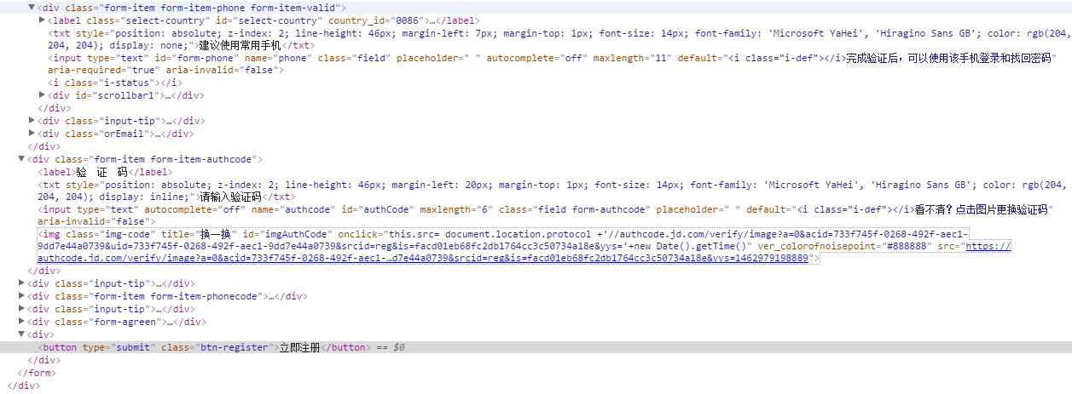

# 支付宝

<https://memberprod.alipay.com/account/reg/index.htm>

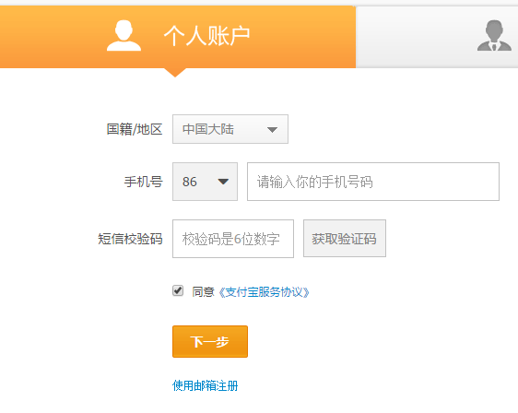

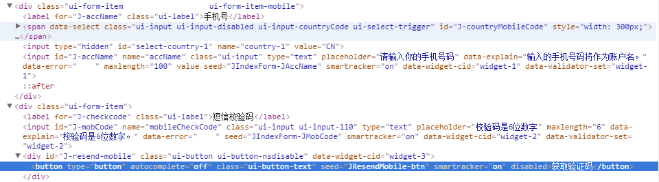

# 搜狐

<https://passport.sohu.com/signup?ru=http://www.sohu.com>

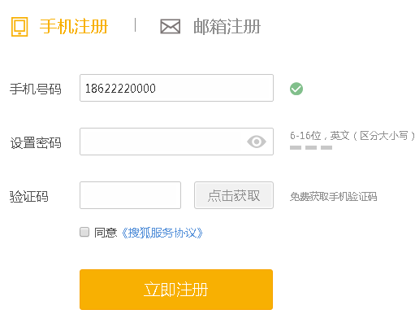

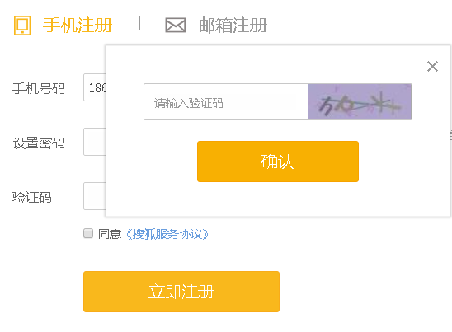

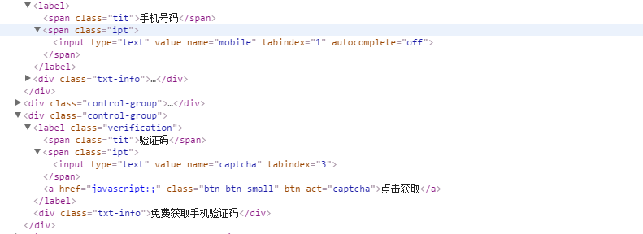

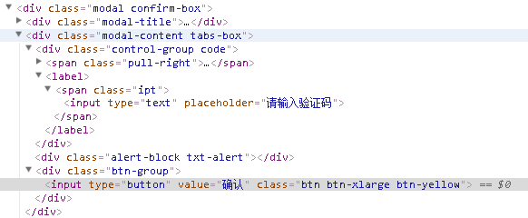

# 360

<http://i.360.cn/reg/?src=pcw_home&destUrl=http%3A%2F%2Fwww.360.com%2F>

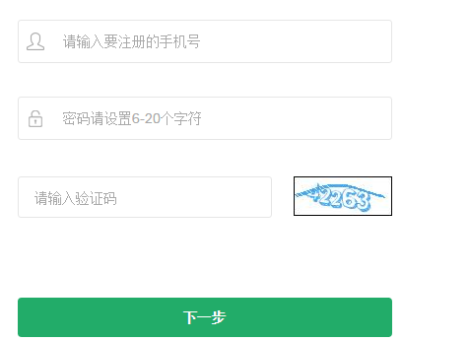

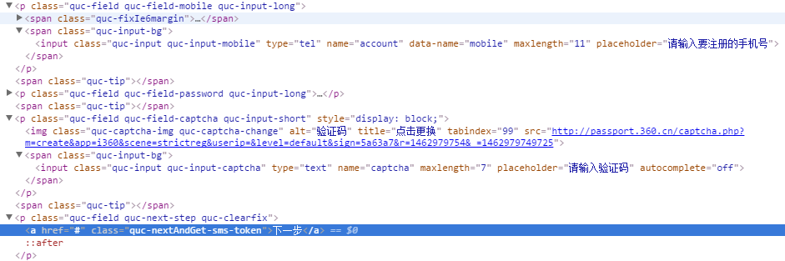

<http://passport.360.cn/captcha.php?m=create&app=i360&scene=strictreg&userip=&level=default&sign=5a63a7&r=1463248869&_=1463248865520>

# 163

<http://reg.email.163.com/unireg/call.do?cmd=register.entrance>

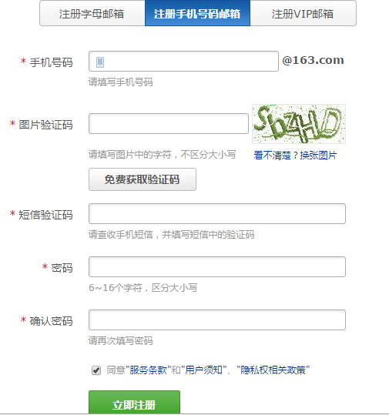

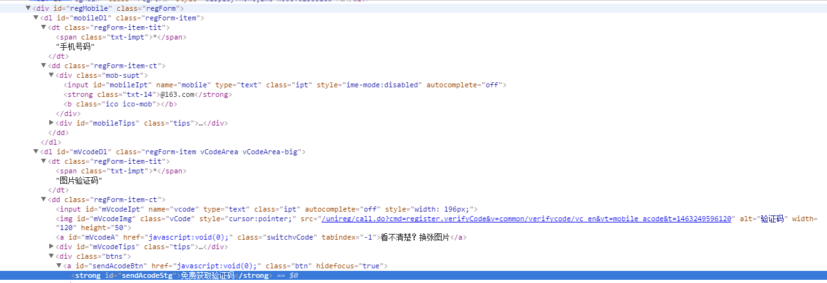

# 人人网

<http://reg.renren.com/xn6218.do?ss=10131&rt=1&f=https%3A%2F%2Fwww.google.co.jp%2F&g=v6reg>

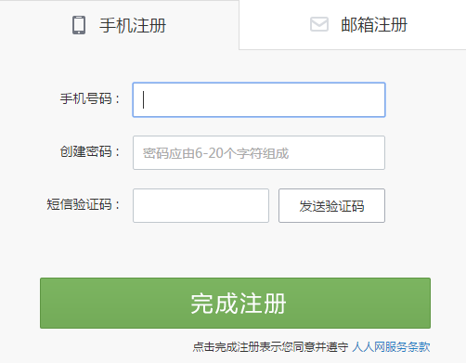

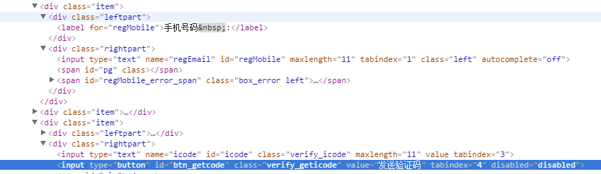

# 聚美优品

<https://passport.jumei.com/i/account/signup?redirect>=

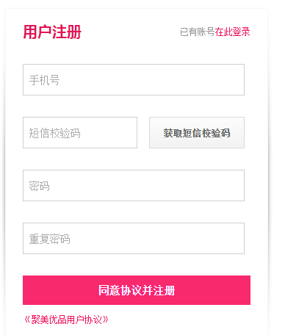

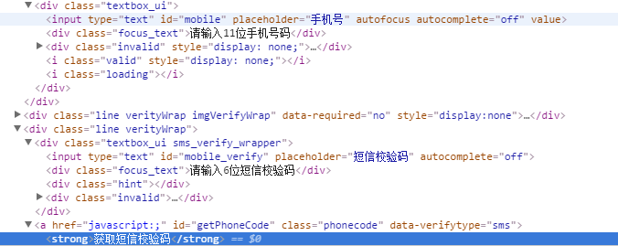

# 优酷

<http://login.youku.com/user_signup?from=header>

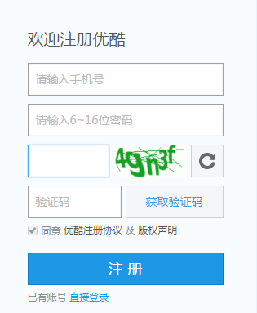

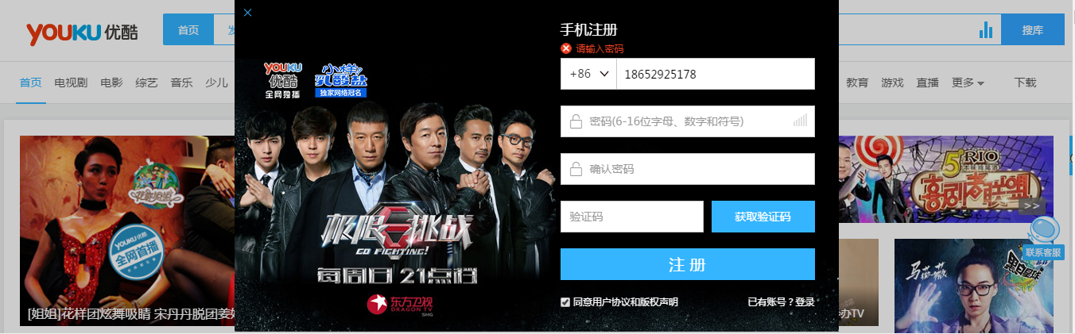

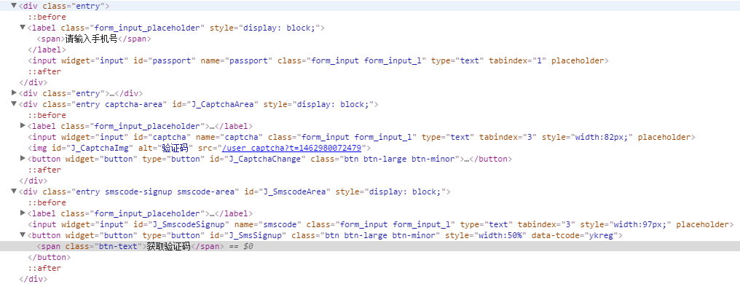

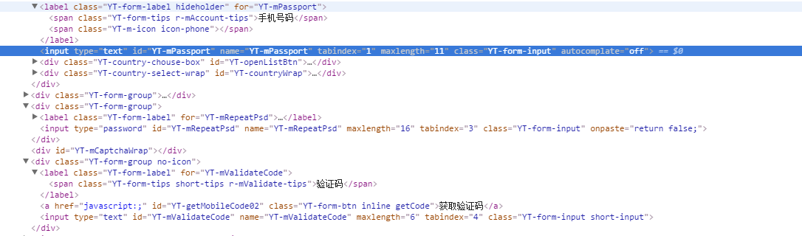

# 爱奇艺

<http://www.iqiyi.com/a_19rrgubrh1.html>



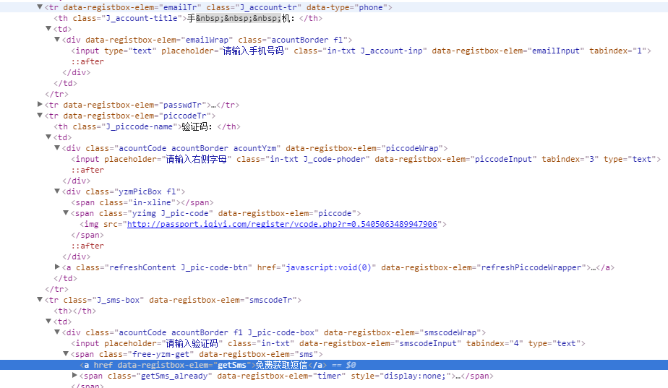

# 有货

<http://www.yohobuy.com/reg.html>

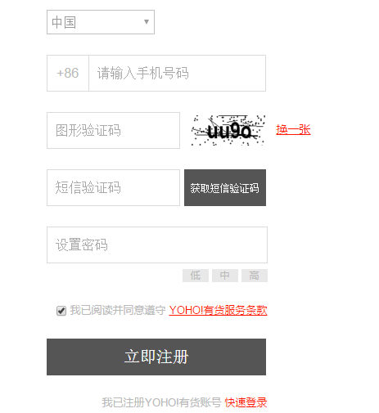

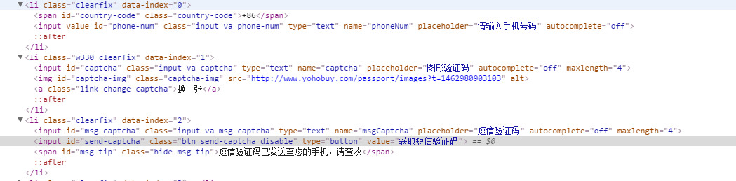

# 响巢

<http://u.kankan.com/register.html?regfrom=KK_001>

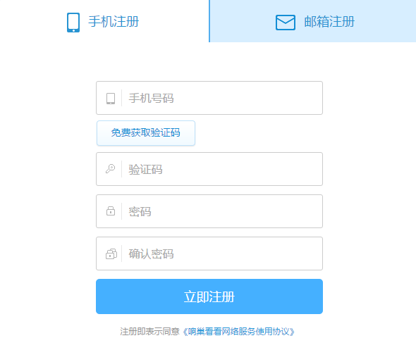

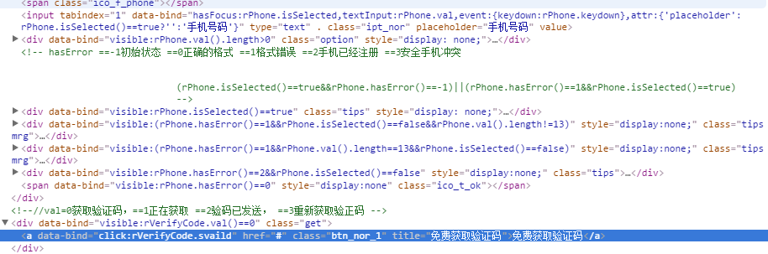

# 酷狗

<http://www.kugou.com/reg/web/>

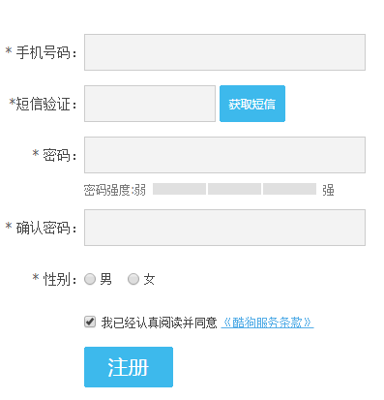

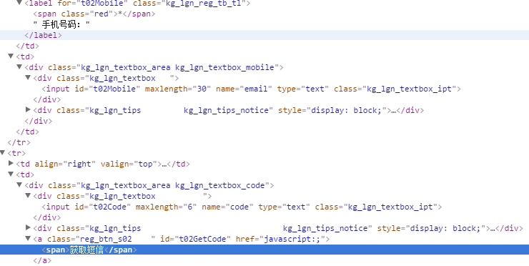

# CSDN

<http://passport.csdn.net/account/mobileregister?action=mobileRegister>

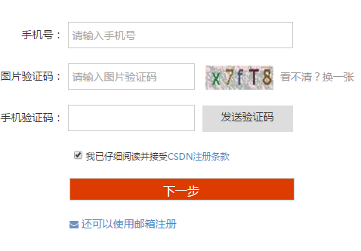

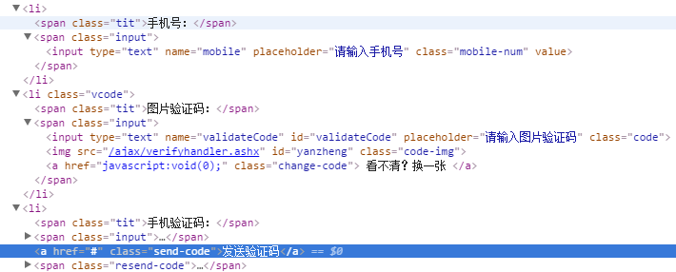

# 126邮箱

<http://reg.email.163.com/unireg/call.do?cmd=register.entrance&from=126mail>

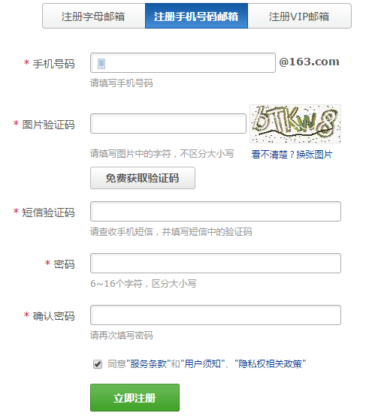

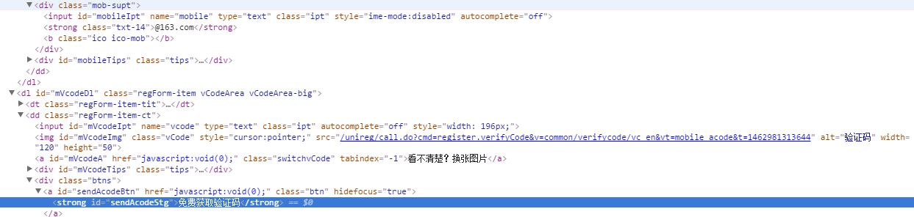

# 赶集网

<http://www.ganji.com/user/register.php?next=http%3A%2F%2Fwei.ganji.com%3A1919%2Fhuangye%2F%3Fautot%3D1%26ca_name%3Dhao123_hao123_042_quanguoshouye%26ca_s%3Dtg_hao123%26ca_n%3D002_shku%26ca_i%3Dad>

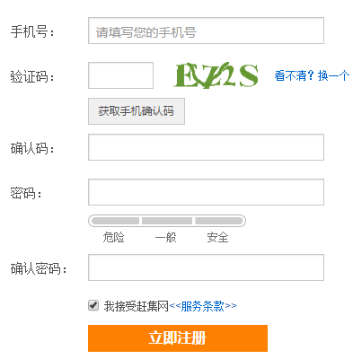

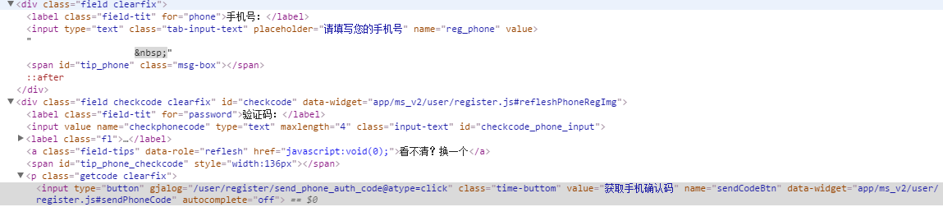

# 易车

<http://i.yiche.com/authenservice/RegisterSimple/MobileRegister.html>

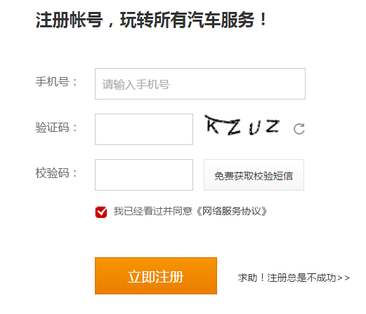

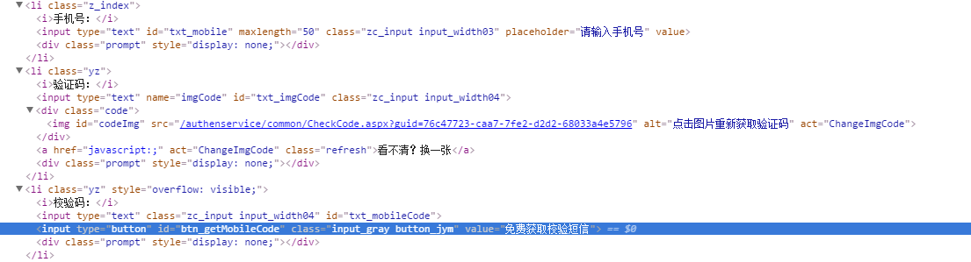

# 哔哩哔哩

<https://passport.bilibili.com/register/phone>

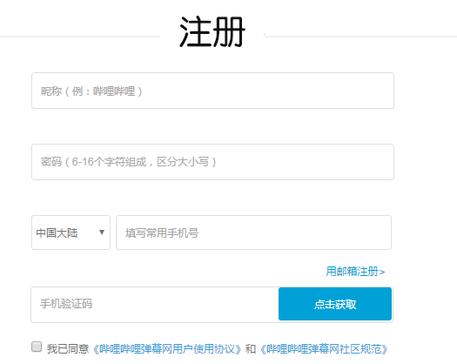

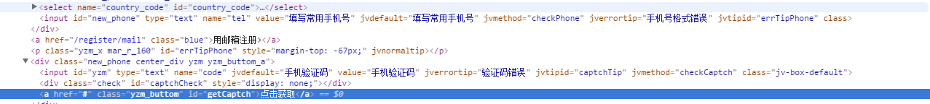

# 39健康网

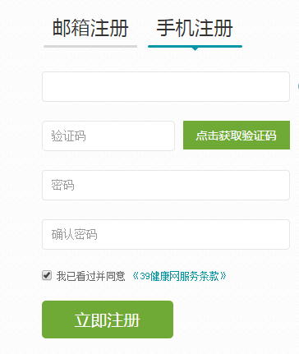

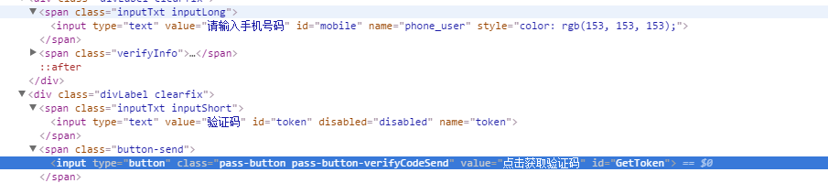

# 国美

<https://reg.gome.com.cn/register/index/person?intcmp=sy-public01003>

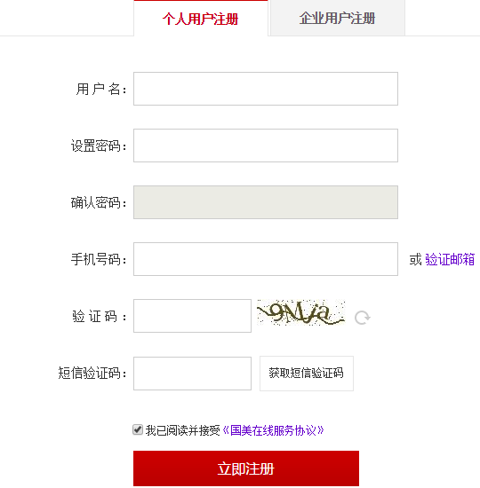

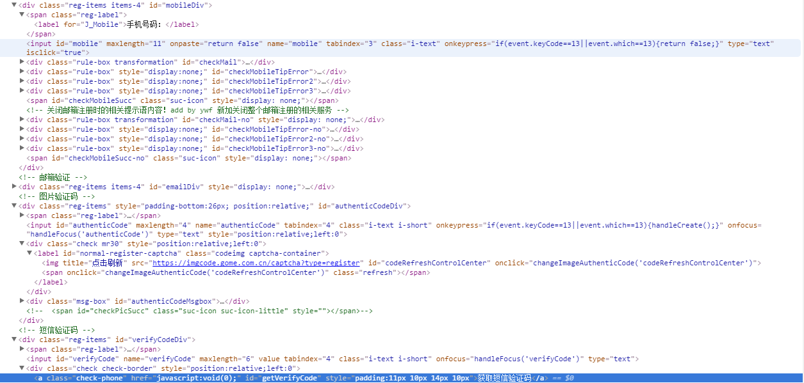

# 中关村在线

<http://service.zol.com.cn/user/login.php?type=reg&backUrl=http://www.zol.com.cn/>

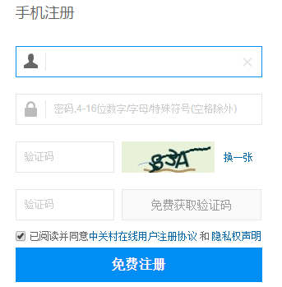

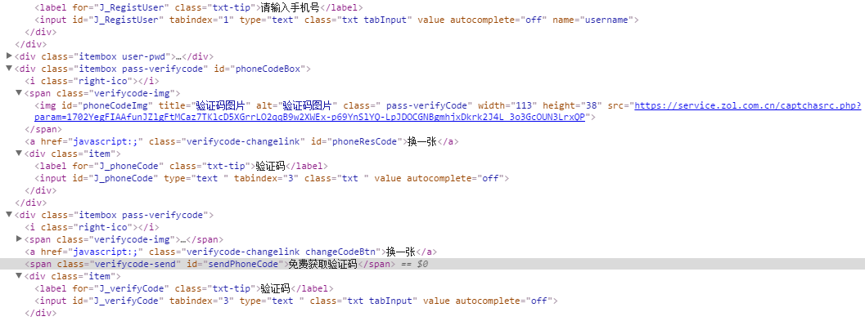

# 139邮箱

<http://mail.10086.cn/>

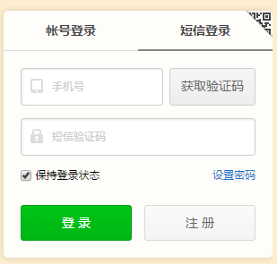

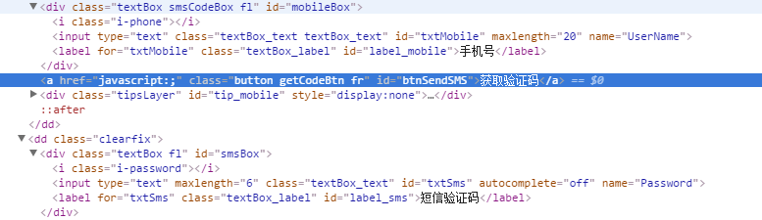

# AcFun

<http://www.acfun.cn/reg/>

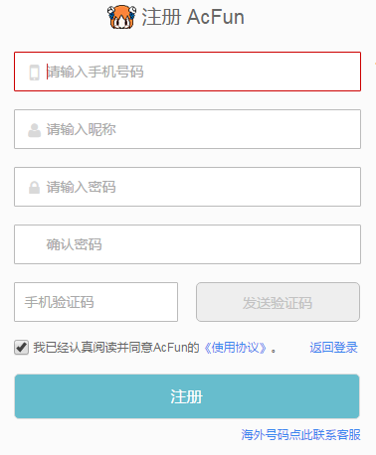

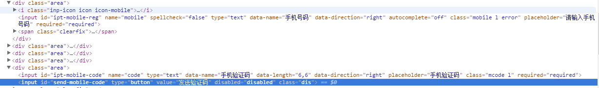

# 去哪网

<https://user.qunar.com/passport/register.jsp?ret=http%3A%2F%2Fwww.qunar.com%2F>

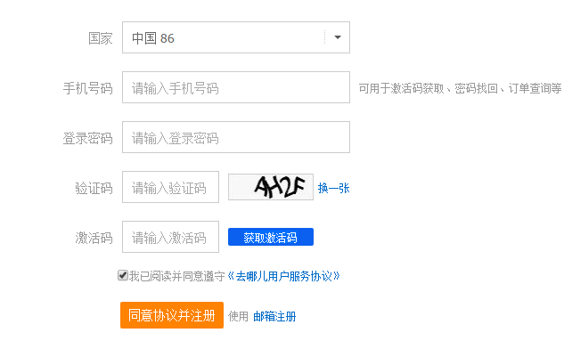

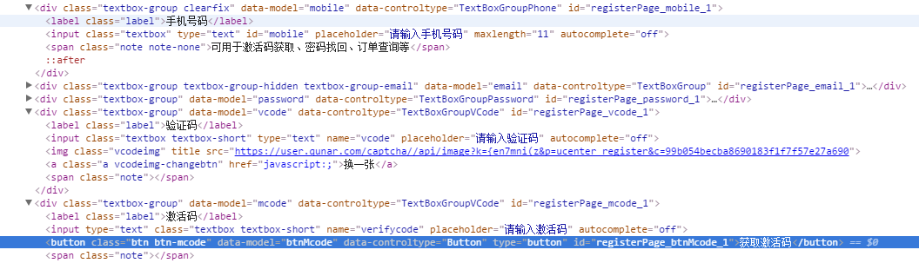

# 唯品会

<http://www.vip.com/?hao123?&utm_source=hao123&utm_medium=textlink&utm_term=201312027&utm_content=&utm_campaign=mz>

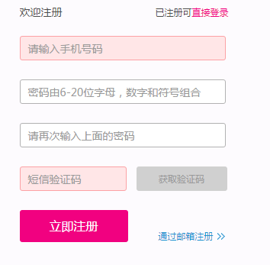

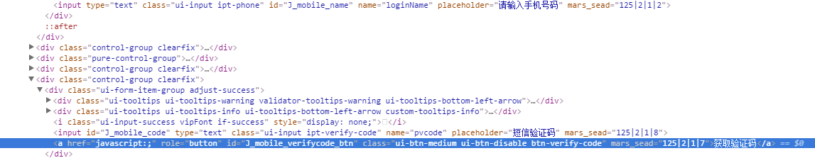

# 途牛网

<http://www.tuniu.com/u/register>

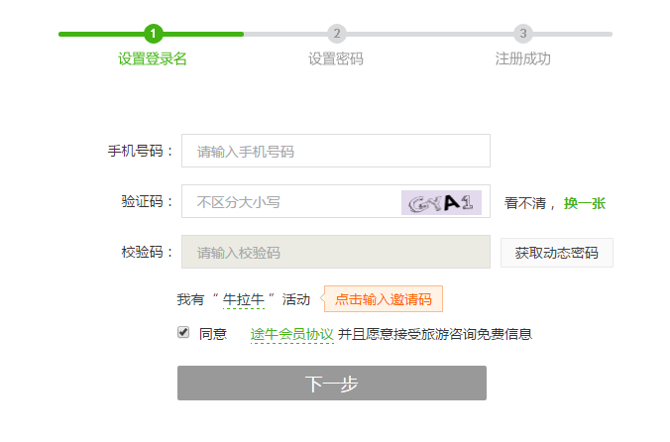

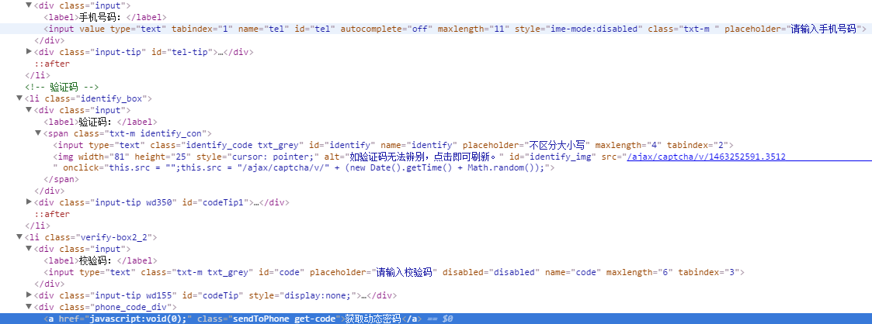

# 豆瓣

<http://www.douban.com/accounts/register>

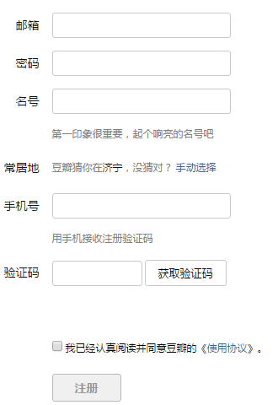

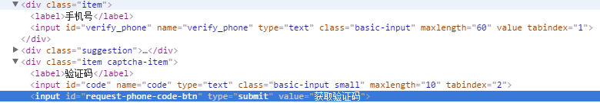

# 凤凰网

<https://id.ifeng.com/user/register>

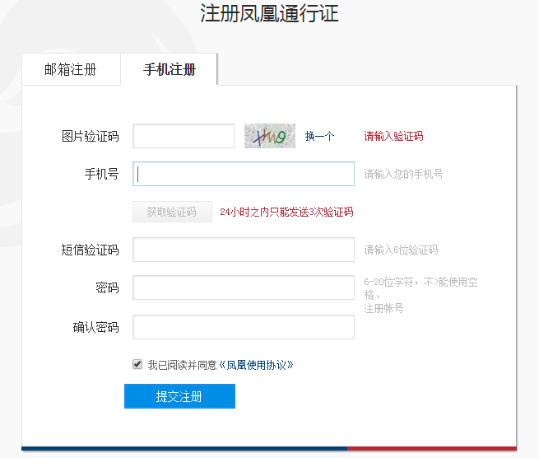

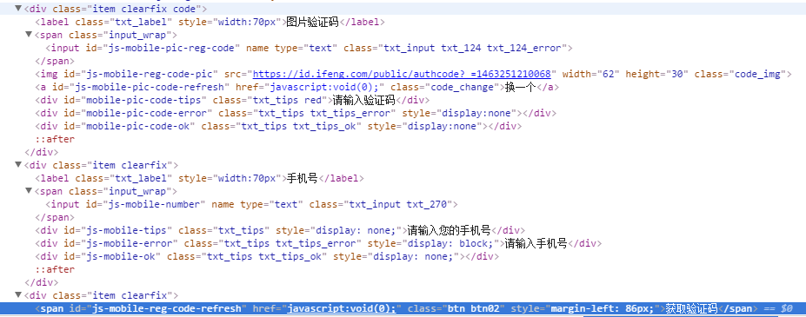

# 招商银行

<https://user.cmbchina.com/User/Cellphoneregister?returnUrl=%2f>

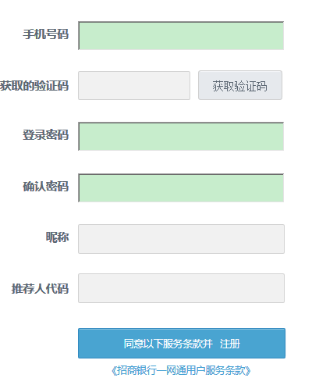

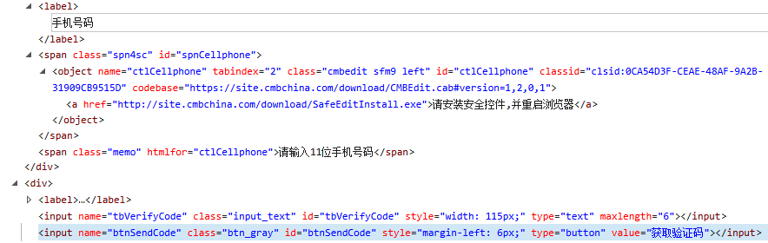

# 申通快递

<http://q1.sto.cn/reg/registerform?callback=%2Freg%2Fregister.html>

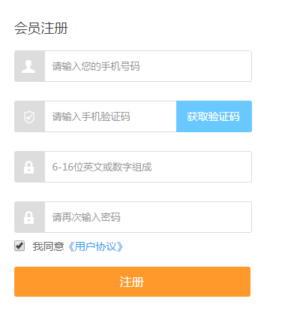

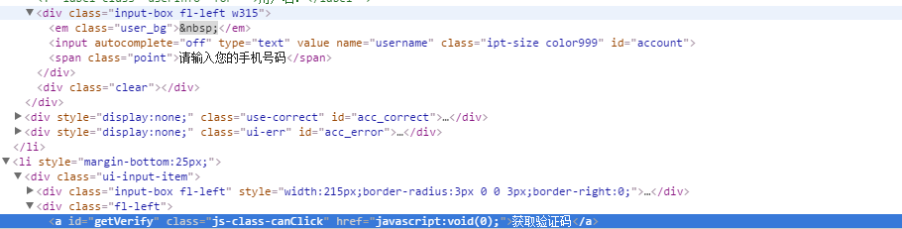

# 广发证券

<https://store.gf.com.cn/#/register>

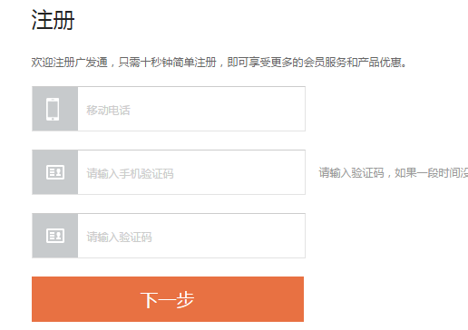

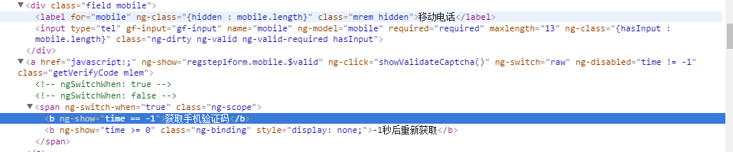

# 联众游戏

<http://id.ourgame.com/regist.do>

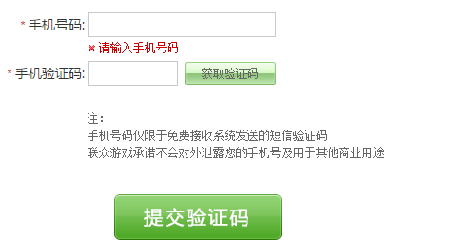

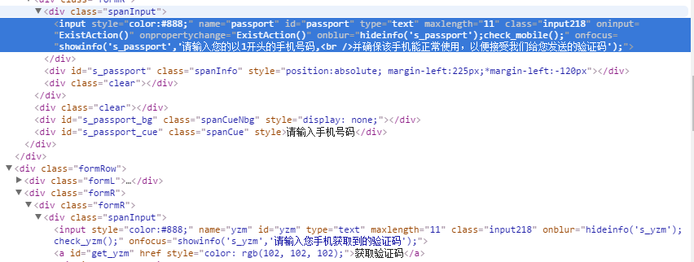

# 虎扑

<https://passport.hupu.com/pc/register?project=www&from=pc>

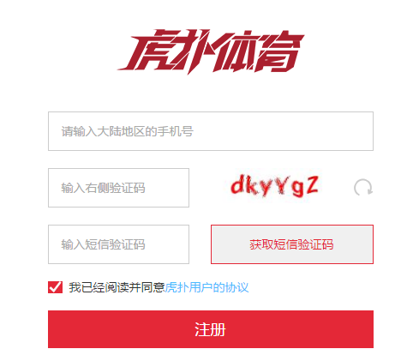

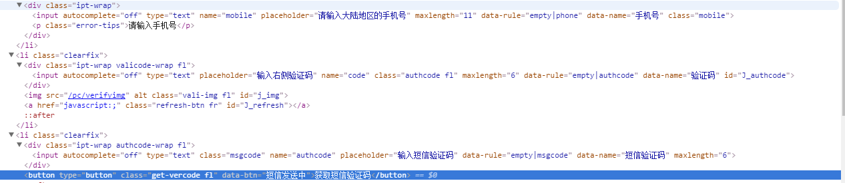

# 17173

<http://passport.17173.com/register>

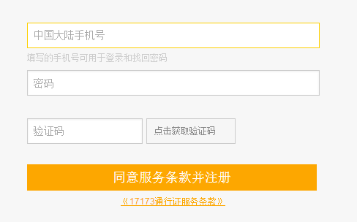

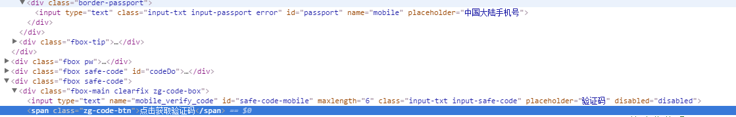

# 4399

<http://www.4399.com/>

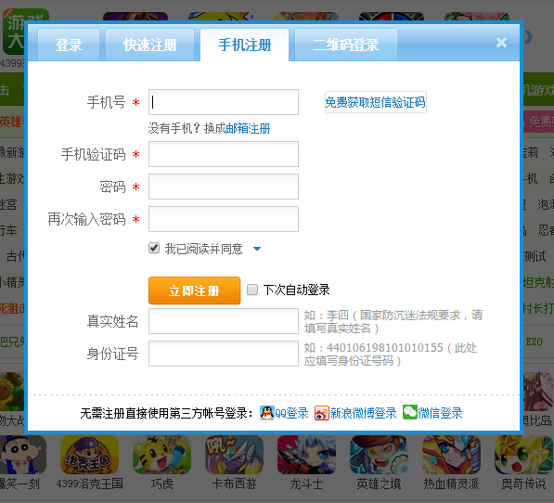

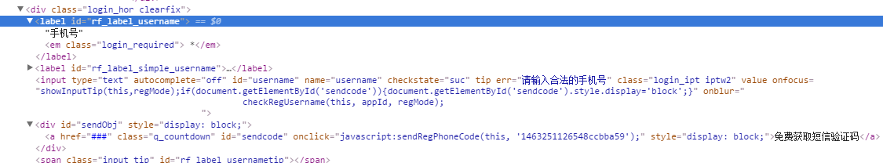

# 华住

<https://passport.huazhu.com//SignUp?redirectUrl=http://www.huazhu.com>

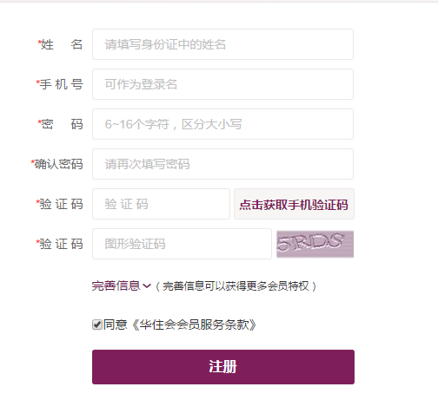

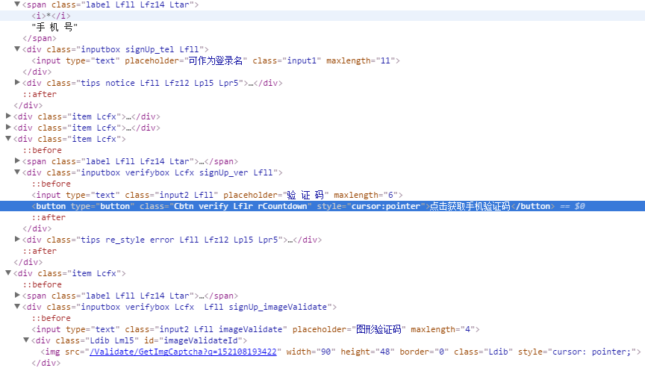

# 遵义人才网

<http://www.zyrc.net/resume/register_mobile.aspx>

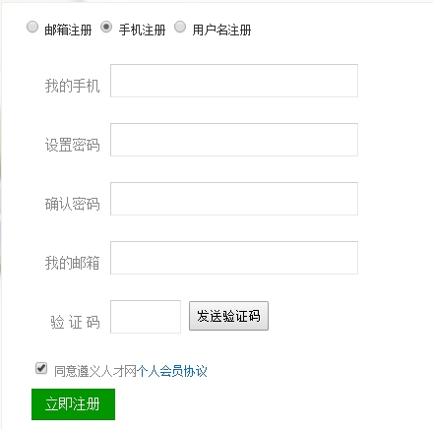

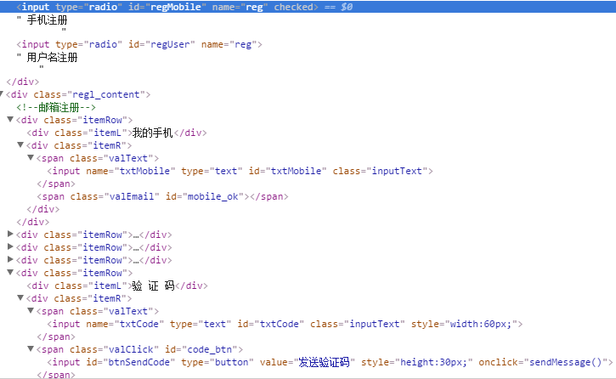

# 第一视频网

<http://passport.v1.cn/login/tologin.do?backurl=http://www.v1.cn/>

